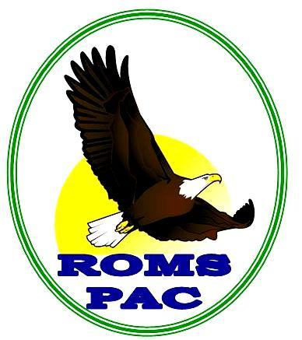 Royal Oak PAC Year End News… June 2015

One of the goals of PAC Executive this past year was to involve many parents in PAC events. We did see great attendance at PAC meetings and thank those parents for taking time out to come and hear school news and lend support to PAC.

With our fundraising this year, PAC sought to support programs at school that touched upon as many students as possible. Below is a listing of some of the programs that PAC supported this year-

- First Nations history (including wood carver and story teller)
- Funds to support a full class set of Chromebooks and iPads for the Learning Commons
- Storage and charging cart for the Learning Commons technology
- Seaquarium maintenance (additionally, Seaquarium science enrichment)
- Supplementary French language cultural supplies
- Band recruiting transportation
- PE dance instruction
- Sports uniforms
- All school presentation on life choices and community involvement by a local Victorian
- Full set of mats for PE class
- Field hockey equipment
- Computer monitor for Extreme Team video editing
- Outdoor volleyball nets

A special thanks to our PAC parent volunteers this year!

We had many parents volunteer to assist with fundraisers- Menchies, COBS hot cross buns, Royals Hockey Game and the Holiday Craft Fair to name a few. There were also many parents organizing the grade 8 farewell, school supplies, working during the grade 6 immunizations and many other initiatives. THANK YOU to the many parents running these programs for the benefit of all students at Royal Oak Middle School.

First PAC meeting for the next school year is going to be Tuesday, September 15^{th, 2015}.

Please note the fundraiser on the flipside of this note- mark your calendars for October 29th. We will need lots of parent volunteers to pull off this event, so grab a friend, and get signed up to help.









Save the date and join us for games, music, contests, dinner and a haunted walk. Fun and scares for the whole family!

Prop Construction starts in August. If you have any interest in donating time or materials, please contact Mary Brooks at marybrookes@shaw.ca

